The Bayeux Tapestry
Newberry Library June 15, 2019
Susanne Dumbleton
http://www.susannedumbleton.com

“The future of two great peoples was at stake, and the final outcome seemed more than once to hang in the balance.
The designer of the tapestry knew this and he had scope, the kind of scope denied to most artists of his time,
cramped by the narrow confines of a page of manuscript. He has space and he knows how to use it.
His achievement towers over the military art of the feudal era.”
Lucien Musset, The Bayeux Tapestry, p. 55

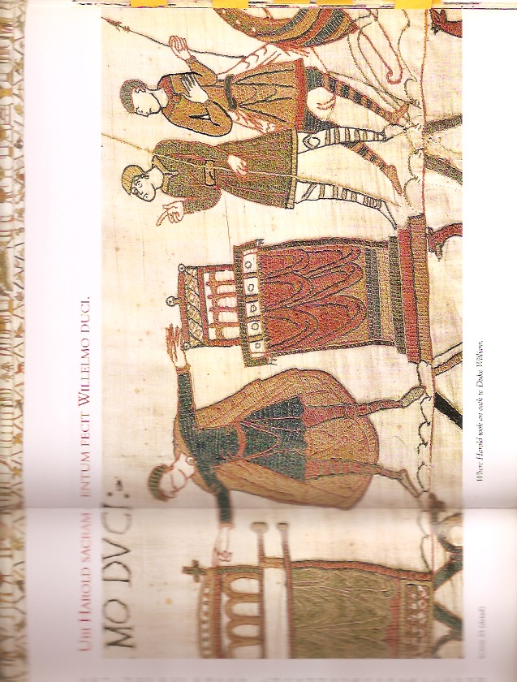
Here Harold took an oath to Duke William

Outline
The Bayeux tapestry is one of the supreme achievements of the Norman Romanesque.... Its survival almost intact over nine centuries is little short of miraculous.... Its exceptional length, the harmony and freshness of its colours, its exquisite workmanship, and the genius of its guiding spirit combine to make it endlessly fascinating.^{[4]}
Sylvette Lemagnen, conservator of the tapestry, in her 2005 book La Tapisserie de Bayeux

Art, History, Narrative, Significance
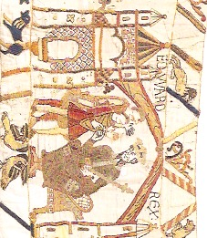
Art: The Tapestry
The object
Artistry in design (including “story”)
Artistry in execution
Artistry in display and preservation

History:
The 11th Century Context
Monarchy and power struggles
Feudal systems evolving
Church and State interdependence

Narrative:
The “characters”
The changing sense of place
The conflicting layers of assumption
The centrality of honor
The noncommittal narrator

Significance of the Tapestry
Contribution to (our) knowledge
Contribution to (their) healing

Full Captions in Latin and English

LATIN
Edwardus Rex. (U)bi Harold dux Anglorum et sui milites equitant ad bosham. Ecclesia. Hic Harold mare navigavit et velis vento plenis venit in terra Widonis comitis.. Harold. Hic apprehended Wido Haroldum et duxit eum at Belrem et ibi eum tenuit. (U)bi Harold et Wido parabolant. Ubi nuntii Willelmi ducis veneruunt ad Widonem. Turold. Nuntii Willelmi. + Hic venit nuntius ad Wilgelmum ducem. Hic Wido adduxit Haroleum ad Wilgelmum Normannorum ducem. Hic dux Wilgelm cum Hroldo venit ad Palatium suum. Ubi unus clericus et aelfyva. Hic Willelm dux et exercitus ejus venerunt ad Motem Michaelis, et hic transierunt flumen Cosnonis et venerunt ad Dol. Hic Harold dux trahebat eos de Arena. Et Conan fuga vertit. Rednes. Hic milites Willelmi ducis pugnant contra Dinantes et Cunan claes porrexit. Hic Willelm dedit Haroldo arma. Hie! Willelm venit Bagias. Ubi Harold sacramentum fecit Willelmo duci. Hic Harold dux reversus est at Anglicam terram et venit at Edwardum regem.

Hic poratur corpus Eadwardi regis ad ecclesiam Sancti Petri apostolic. (hic) Eadwardus res in lecto alloquitur fideles, et hic defunctus est. Hic dederunt Haroldo coronam regis. Hic residet Harold rex Anglorum. Stigant Archipiscopus. Isti mirant stella(M). Harold. Hic navis anglica venit in terram Willelmi ducis. Hic willelm dux jussit naves edificare. Hic trahunt naves ad mare. Isti portant armas et hic trahunt carrum cum vino et armis. + Hic William dux in magno navigio mare transvit et venit ad pevenese. Hic est Wadard. Hic coquitur caro et hic ministraverunt ministry. Hic fecerunt prandium et hic episcopus cibu(m) et potum benedicit. Odo espicopus. Willelm. Rotbert. Iste jussit ut foderetur castellum “at Hestenga ceastra”. Hic nuntiatum est willelmo de Harold. Hic domus incenditur.

Hicmilites exierunt de Hestenga et venerunt ad prelium contra haroldum rege(m). Hic Willelm duxinterrogat Vital si vidisset exercitum Haroldi. Iste nuntiat Haroldum ex exercitu Willelmi ducis. Hic Willelm dux alloquitur suis militibus ut prepararent se viriliter et sapienter at prelium contra Anglorum exercitum. Hic cediderunt Lewine et Gyrt fratres Haroldi regis. (Hic cedierunt simul Angli et Franci in prelio. Hic Odo espicopus baculum tenens confortat pueros. His est Willelm dux. E(usta)tius. Hic Franci pugnant et cedirerunt qui errant cum Haroldo. Hic Harold res interfectus est.

ENGLISH

King-Edward. Where Harold, Duke of the English, and his knights ride to Bosham. The church. Here Harold sailed by sea and with wind-filled sales arrived in the land of Count Wido. Here Wido apprehended Harold and took him to Beaurain and held him there. Where Harold and Wido parlay. Where messengers of Duke William came to Wido. Turold. Williams’s messengers. + Here a messenger comes to Duke William. Here Wido took Harold to William, Duke of the Normans. Here Duke William came with Harold to his palace. Where one cleric and Aelfgyva. Here Duke William and his army came to Mont (Saint) Michel, and here they crossed the River Couesnon and came to Dol. Here Duke Harold dragged them from the sand. And Conan turned and fled.

Rennes. Here Duke William’s knights fight against Dinan and Conan hands over the keys. Here William gave arms to Harold. Here William came to Bayeux. Where Harold took an oath to Duke William. Here Duke Harold retuned to the English land and came to King Edward. Here the corpse of King Edward is borne to the church of the Apostle Saint Peter. Here King Edward speaks with his followers on his bed, and here he died. Here they gave the king’s crown to Harold. Here sits Harold, King of the English. Archbishop Stigand. They wonder at the star. Harold. Here an English ship comes to the land of Duke William. Here Duke William ordered ships to be built. Here they drag the ships to the sea. These men carry weapons to the ships and here they drag a cart laden with wine and weapons. +

Here Duke William crossed the sea in a great ship and came to Pevensey. Here the horses leave the ships. And here the knights hurried to Hastings to get food. Here is Wadard. Here meat is cooked and here servants serve it. Here they have a meal and here the bishop blesses the food and drink. Bishop Odo. William. Robert. The latter ordered that a castle should be dug at Hastings. Here William is told about Harold. Here a house is burned. Here knights leave Hastings and came to fight against King Harold. Here Duke William asks Vital if he had seen Harold’s army. He tells Harold about Duke William’s army. Here Duke William tells his soldiers to prepare themselves manfully and wisely for the battle against the army of the English. Here fell Leofwyne and Gyrth, King Harold’s brothers. Here English and French fell together in the fight. Here Bishop Odo, holding his staff, encourages the lads. Here is Duke William. Eustace. Here the French fight and those who were with Harold fell. Here King Harold is slain.

Translation by Richard Rex

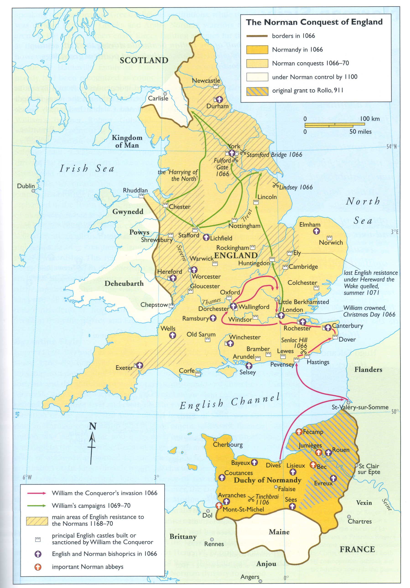

The Battle of Hastings, October 14, 1066, Duc William’s Sea and Land Route.

“The future of two great peoples was at stake, and the final outcome seemed more than once to hang in the balance. The designer of the tapestry knew this and he had scope, the kind of scope denied to most artists of his time, cramped by the narrow confines of a page of manuscript. He has space and he knows how to use it.
His achievement towers over the military art of the feudal era.”
Lucien Musset, The Bayeux Tapestry, p. 55

Significance: “For all the delicate questions it raises, the Tapestry is universally recognized as one of the principal sources for the maritime archaelogy of the Middle Ages. In artistic terms, it is also the most successful depiction of a fleet on the high seas between the ceramics of the Greeks and the early modern era: other attempts at such scenes in Romanesque art and medieval illumination are crude and schematic, in settings too restricted to do justice to the subject. But in the embroidery of the tapestry, there is a real sense of the sea, of open waters really traversed by the fleets, and not merely of coast-hugging vessels or particular incidents. As with the calvary action in the battle scene, one feels here that rare gift, the blending of first hand experiences with authentic artistic inspiration in a rendering of a great event in its full breadth. And yet this neither detracts from the historical value of the images nor from their narrative impact: each tableau deserves consideration in its own right.” Lucien Musset The Bayeux Tapestry, p. 65

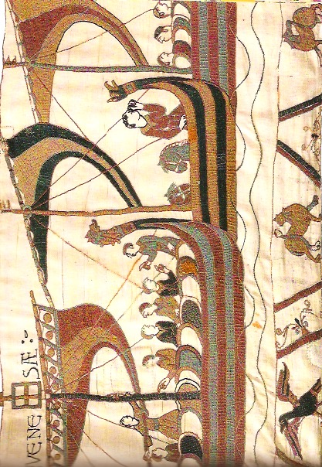

The Aftermath
“Experts reckon that the English army did not reach the battlefield until the evening of Friday 13 October, and that the Norman forces did not take up their positions until dawn of the following day. Battle was joined at about 9:00, and the English put up a fierce resistance until about 17:00. The subsequent butchery went on until nightfall. This was, therefore, a particularly long and bitter struggle, which must have cost thousands of lives. Norman losses are estimated at between a quarter and a third of those present, and English casualties must have been far heavier.

The Normans spent Sunday burying their dead, and then regrouped at Hastings before resuming the advance into England. William headed first for Dover and Canterbury, and then made for Winchester, bypassing but also cutting off London, which he returned by agreement on Christmas Eve. His coronation took place at Westminster on Christmas Day, a little less than a year after Edward’s death.”
Lucien Musset, p. 264
Narrative: Debates and Meaning
Who were the artists and artisans?
Where was the workshop?
Why Bayeux?
Unique content for scholars of history, agriculture, architecture, military
Science (combat, weaponry, clothing); shipbuilding; nautical; horsemanship etc.

Further Reading and viewing: All Available at http://www.susannedumbleton.com

Musset, Lucien. The Bayeux Tapestry, Tr. Richard Rex. Woodbridge: The Boydell Press, 2005.
Wilson, David MacKenzie. The Bayeux Tapestry. London. Thames and Hudson, 2005.

- Comprehensive bibliography with excellent links:
http://users.clas.ufl.edu/burt/middleagesonfilm/bayeux1.html
- Image of tapestry as hung in cathedral:
http://holythequest.com/wp-content/uploads/2016/06/img_0398.jpg
- Scrollable tapestry:
http://www.bayeux-tapestry.org.uk
http://www.hs-augsburg.de/~harsch/Chronologia/Lspost11/Bayeux/bay_tama.html
- Animation (4 min):
https://www.youtube.com/watch?v=LtGoBZ4D4_E
- Graphic rendering of battle (11 Min)
https://www.youtube.com/watch?v=FW4RKp23Z4M

